Run length coding can be used as a form of compressing data such as images or text to smaller numbers to send out into the world. Some of the most common examples are live television or social media sites like twitter or Facebook. Recently though, we have finally received images of our observable universe from the James Webb telescope in space. To process these images all the way from outer space, they needed a way to send these images in signals use the least amount of data as possible. One of the simplest ways is to compress the images taken is using RLE code to send back to earth. These images are a gateway to exploring and understanding what is beyond the limits of our observable universe. Once the infrared images are encoded and sent back to earth, we can receive the signal waves and recreate the image for the world to see. It may use other means to take the images, but to save as much time as possible in such a massive distance. RLE code in the smallest compressed file possible can save scientists time to start the study of the new universe.

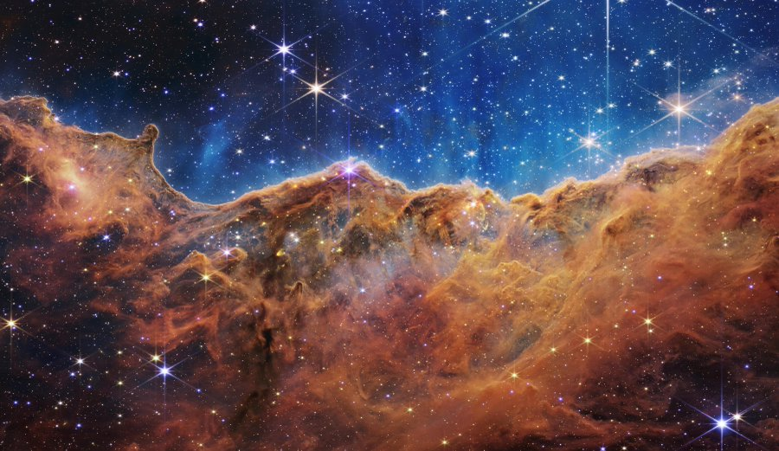

NASA. (n.d.). *First images Gallery*. WebbTelescope.org. Retrieved July 15, 2022, from https://webbtelescope.org/news/first-images/gallery

NASAtelevision. (2022, July 13). *Highlights: First images from the James Webb Space Telescope (official NASA video)*. YouTube. Retrieved July 15, 2022, from https://www.youtube.com/watch?v=1C_zuHf6lP4&t=192s